**Brain Tumor (Glioblastoma) Segmentation using Neural Networks**

**Team 10**

Team members: Tego Chang, Jaya Khan, Satvik Kishore, Fides Schwartz

1. ***Motivation****.*

We would like to pursue an image segmentation problem regarding brain tumors on MRI images. Glioblastoma multiforme (GBM) is a WHO grade IV brain tumor which represents one of the most lethal human cancers, with a 5-year survival rate of only 7.2% (1). The incidence of GBM increases with age and shows the highest incidence in the 75–84-year old age group in the United States (2). The incidence is higher in men than women, as well as in Caucasians than in other ethnicities (3). The first line therapy is usually surgery, followed by radio-chemotherapy. MRI-guided surgery has been established as the method of choice for years, relies on the ability of the surgeon to distinguish the tumor tissue from healthy brain tissue, and is crucial for patient outcomes (4, 5). We would like to segment glioblastoma multiforme based on MRI images, which could be helpful for surgical planning, e.g. when trying to determine how close the tumor is to important areas of the motor cortex. We believe this is worth pursuing, because there is a gap between imaging specialists (radiologists), who are used to seeing 2D images in sequence and transforming them into a 3D image in their head while “reading” a scan and surgeons (neurosurgeons), who are used to seeing and touching the actual tumor tissue but not to translating 2D-image data into the 3D tumor they are confronted with in the operating room (6, 7). The planning and surgical approach might benefit from better tumor segmentation, based on the pre-operative MRI scans. In addition, radiotherapy volumes could be planned in a more comprehensive manner and disease progression monitoring could be improved.

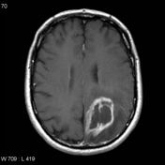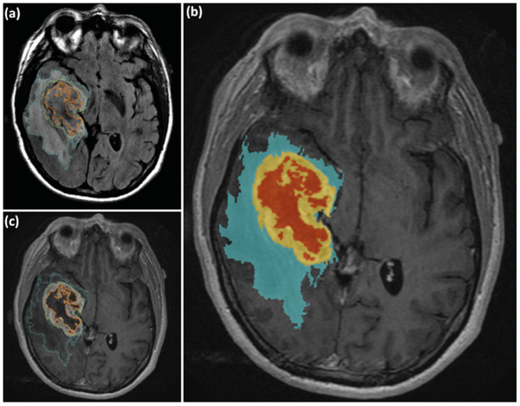

Left: Example of a glioblastoma multiforme (<https://radiopaedia.org/articles/glioblastoma-idh-wildtype?lang=us>); the tumor is in the lower right part of the brain and shows typical rim-enhancement (white line around darker area). Right: Idea for how this kind of segmentation could look with the edema surrounding the tumor in blue, the enhancing rim in yellow and internal tumor necrosis in red (https://journals.plos.org/plosone/article/figures?id=10.1371/journal.pone.0025451).

2. ***Data****.*

Fides Schwartz has signed up for the Radiological Society of North America (RSNA) dataset on glioblastoma multiforme (<https://www.synapse.org/#!Synapse:syn25953134>), which was released as part of an RSNA challenge in 2021 (BraST Challenge: <https://www.synapse.org/#!Synapse:syn25829067/wiki/610863>). This dataset uses multi-institutional multi-parametric magnetic resonance imaging (mpMRI) scans, and permits the evaluation of state-of-the-art methods for the segmentation of intrinsically heterogeneous brain glioblastoma scans. This dataset makes publicly available the largest and most diverse retrospective cohort of glioma patients. Ample manually-annotated multi-institutional routine clinically-acquired mpMRI scans of glioma are used as the training, validation, and testing data. Ground truth annotations of the tumor are created and approved by expert neuroradiologists for every subject included in the training, validation, and testing datasets to quantitatively evaluate the predicted tumor segmentations. All BraTS mpMRI scans are available as NIfTI files (.nii.gz) and describe a) native (T1) and b) post-contrast T1-weighted (T1Gd), c) T2-weighted (T2), and d) T2 Fluid Attenuated Inversion Recovery (T2-FLAIR) volumes, and were acquired with different clinical protocols and various scanners from multiple data contributing institutions.

All the imaging datasets have been annotated manually, by one to four raters, following the same annotation protocol, and their annotations were approved by experienced neuro-radiologists. Annotations comprise the gadolinium-enhancing tumor (ET — label 4), the peritumoral edematous/invaded tissue (ED — label 2), and the necrotic tumor core (NCR — label 1). The ground truth data were created after their pre-processing, i.e., co-registered to the same anatomical template, interpolated to the same resolution (1 mm3) and skull-stripped.

There are 570 cases in the training and 219 cases in the validation set.

3.***Methods.***

We plan to use Deep Learning Methods specialized in the class of problems known as Semantic image Segmentation. In semantic segmentation, our goal is to classify each pixel in the input image. We will segment each pixel in the MRI scan to be either gadolinium-enhancing tumor (ET — label 4), the peritumoral edematous/invaded tissue (ED — label 2), the necrotic tumor core (NCR — label 1), and any not belong to the previous three, which is unaffected brain tissue.

The architecture of the neural network will be that of a U-Net. 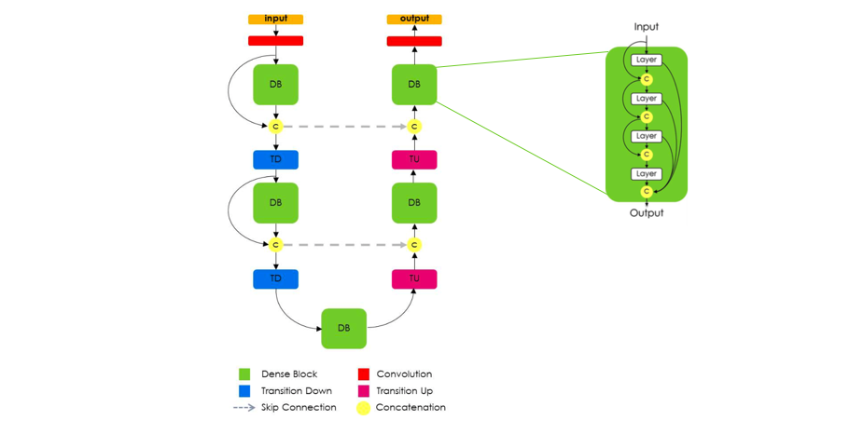

<https://www.jeremyjordan.me/content/images/2018/05/Screen-Shot-2018-05-20-at-3.42.24-PM.png>

This resembles an encoder-decoder network where the first half of the network is a series of convolutional layers that decrease the size of the image after each layer while increasing the number of channels, culminating into a single dense layer composed of many channels and 1 pixel. The second half of the network converts this dense layer back to an image of the dimension as that of the input image, but with the number of channels equal to the number of possible output classes. Thus, the final output will represent the probabilities of each pixel belonging to each of the classes. Since we cannot expect the encoder-decoder mechanism to accurately form borders at the pixel-level, we add skip layer connections connecting across the “U” to guide the formation of pixel-level outputs.

We plan to train these models on Google-Colab to take advantage of the free GPUs. We may need to explore other computational resource offerings if the free-tier of Google Colab does not fit our needs. We will be taking advantage of the well-established deep learning framework Tensorflow. We will also be looking into transfer learning to leverage the power of existing models trained on larger datasets.

4. ***Experiments***

We will use cross validation and associated Dice scores to examine the performance of our model.

In addition, performance will be evaluated via spot-checking for accuracy of segmentation by Fides Schwartz, who has domain knowledge of brain MRI (board certified radiologist, Switzerland). The training and validation data is already separated as part of the challenge, though we may have to split the validation dataset further to obtain a test set, since we do not have the opportunity to submit our work to the challenge anymore (which evaluated performance on a test set that was not provided for download). As of January 2022 the challenge providers were still accepting submissions from groups that are not competing but would like their models evaluated against the test set, so we might be able to do that, too.

5. ***Roles***

Tego Chang: programming neural network for segmentation of brain tumors

Jaya Kahn: programming neural network for segmentation of brain tumors

Satvik Kishore: programming neural network for segmentation of brain tumors

Fides Schwartz: accessing the dataset, providing domain knowledge about MRI imaging of glioblastoma multiforme, spot-checking segmentation experiments

6. ***References***

1. Wu, W., et al. (2021). "Glioblastoma multiforme (GBM): An overview of current therapies and mechanisms of resistance." Pharmacological Research 171: 105780.
2. A. Oszvald, E. Güresir, M. Setzer, H. Vatter, C. Senft, V. Seifert, K. Franz. Glioblastoma therapy in the elderly and the importance of the extent of resection regardless of age, J. Neurosurg. 116 (2) (2012) 357–364.
3. M.E. Davis, Glioblastoma: overview of disease and treatment, Clin. J. Oncol. Nurs. 20 (5 Suppl) (2016) S2–S8.
4. M. Lacroix, D. Abi-Said, D.R. Fourney, Z.L. Gokaslan, W. Shi, F. DeMonte, F. F. Lang, I.E. McCutcheon, S.J. Hassenbusch, E. Holland, K. Hess, C. Michael, D. Miller, R. Sawaya, A multivariate analysis of 416 patients with glioblastoma multiforme: prognosis, extent of resection, and survival, J. Neurosurg. 95 (2) (2001) 190–198.
5. D.G. Barone, T.A. Lawrie, M.G. Hart, Image guided surgery for the resection of brain tumours, Cochrane Database Syst. Rev. 1 (2014).
6. Krupinski EA. Current perspectives in medical image perception. Atten Percept Psychophys. 2010;72(5):1205-1217. doi:10.3758/APP.72.5.1205
7. Mascagni, P, Longo, F, Barberio, M, et al. New intraoperative imaging technologies: Innovating the surgeon’s eye toward surgical precision. J Surg Oncol. 2018; 118: 265- 282. <https://doi.org/10.1002/jso.25148>
8. <https://www.jeremyjordan.me/semantic-segmentation/>
9. https://nanonets.com/blog/semantic-image-segmentation-2020/